Community Health Centers of Cincinnati and

Hamilton County COVID-19 Testing

There are three different types of tests for COVID-19 (coronavirus).
We are offering two types of tests: the rapid antigen test and the PCR test.
We are not offering antibody tests.

Rapid Antigen tests

The rapid antigen test is a new test that takes 15 minutes and is collected by nasal swab. The rapid antigen test looks for these viral particles in your nose. If your test is positive, it means that you most likely have coronavirus, and you can pass the infection to others. If your test is negative, there is still a chance you could have coronavirus. You should talk with your health care provider if you have symptoms to determine if you need a PCR test.

Antibody tests

Antibody tests show if you have had the infection in the past. Antibody tests are done through a blood test. If positive, you may or may not have an active infection and be contagious. If you have antibodies, we do not know if you can get the coronavirus infection in the future, or if you can pass it on to others.

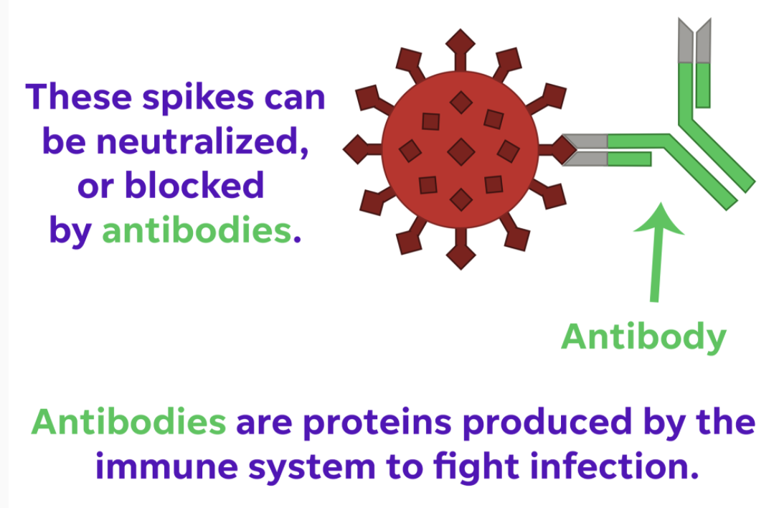
Antigens are proteins on the outside of the virus that the virus uses to infect the body.

PCR tests

The PCR test looks for genetic material from the coronavirus. This test is collected by a nasal swab and usually takes 2-3 days to come back. If your test is positive, it means you most likely have coronavirus, and you can pass the infection on to others. If your antigen test is negative and you have symptoms, we encourage you to also have the PCR test.

